Multiple Genome Rearrangement
David Sankoff, Mathieu Blanchette
Annual Conference on Research in Computational Molecular Biology
pp. 243-247, 1998
Abstract
We first review some formulation of multiple alignment and show which have counterparts in multiple rearrangement, then we discuss an approach of multiple rearrangement, based on breakpoint analysis.
- Multiple Sequence Alignment

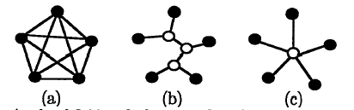

- The analogy of genome rearrangement
- Breakpoint Analysis
- Ex.
={3,5,6,7,2,1,4,8} to

L 3 5 6 7 2 1 4 8 R

- 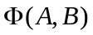: the number of breakpoints in A

- Binary Tree-based Rearrangement
- Problem definition:
Let T=(V,E) be an unrooted tree with N3 leaves and ={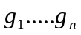} be a set of genes. Suppose {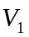….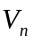}V(T) are the leaves of the tree and {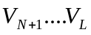}, where N<L2N-2, are the internal vertices of the tree, The data consist, for each leaf 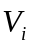, 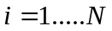, of a circular permutation 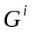=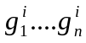 of the genes in . The task is to find the permutations 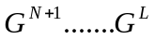 associated with the internal vertices , such that
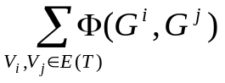
is minimized.

- Algorithm:
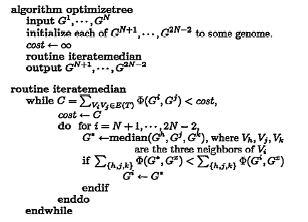

- The median routine
- Example
- Tree-based rearrangement
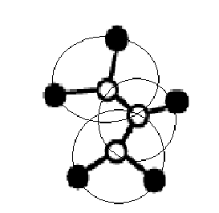

- 3-star

Let to be the complete graph whose vertices are the elements of , assume that 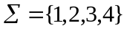

for each edge gh in E(), let 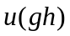 be the number of times g and h are adjacent in the N data genomes, Set 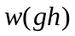=N-
1 2
● ●

● ●
- 4

Created by: Hung-Wei Huang
Date: May 23, 2003

